Name :Adnan Habib Khan

Roll no: l1f16bscs0578

Sec : E

Q1

input type="paragrapg" name="adnan"

Q2

<file:///C:/Users/Adnan%20Habib/Desktop/html%20practice/practice.html>

q3

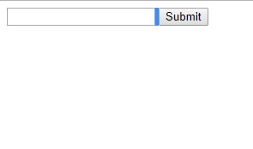

Q4

<file:///C:/my-handling-form-page?name=&reg>=

Q5

Open google web page

Q6

<https://www.google.com/search?q=q>

q7

https://www.google.com/search?q=q

q8

yes,file was no found

<file:///C:/form-handler>

q9

file:///C:/my-handling-form-page?q=aliraza

q10

file:///C:/my-handling-form-page?g=on

q11

file:///C:/my-handling-form-page?h=on&q=on

q12

file:///C:/my-handling-form-page?g=on&h=on&q=on

q13

file:///C:/my-handling-form-page?q=two

q14

file:///C:/my-handling-form-page?q=three

q15

file:///C:/my-handling-form-page?q=two

Q16

<file:///C:/my-handling-form-page?q=1>

<file:///C:/my-handling-form-page?q=the+last+three>